Copyright for test papers and marking guides remains with West Australian Test Papers.
They may only be reproduced within the purchasing school according to the advertised Conditions of Sale.
Test papers should be withdrawn after use and stored securely in the school until Friday 4th December 2009.

PHYSICS 2009
YEAR 11
2B

YEAR 12


Solutions

Section A
Q1. (a) The Esky case is made of foam and as such is a good insulator.
The warm liquid is in thermal contact with the cool ice so heat will flow such
that the drink becomes colder. (3 marks)
(b) Latent heat of water (ice) is huge so takes a long time for ice to melt in
an insulated environment. (1 mark)
Q2. (a) C (2 marks)
(b) The circuit is a series circuit so the identical current flows in each wire (2 marks)
Q3. (a) 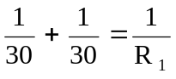
R_{T} = 15 Ω so R (total) = 15 + 25 = 40 Ω  (3 marks)
(b) 25 Ohm (no explanation needed) (1 mark)
Q4. (a) Face North to capture most sun during the day. (2 marks)
(b) Heat in = 2 x 800 x 30 x 60 = 2.88 x 10⁶ J
2.88 x 10⁶ = 15 x 4180 x  ∆T
∆T = 45.9 ⁰C (3 marks)
Q5. (a) 0.25 x 3500 x 25 = m (3.36 x 10⁵ + 4180 x 5)
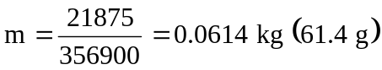 (4 marks)
(b) Stir, crush ice, cool drink in insulated cup (any one) (1 marks)
Q6. (a) Q = 05 x 4180 x 75 = 1.57 x 10⁵ J (2 marks)
(b) Q = 0.25 x 2.26 x 10 ⁶ J = 5.62 x 10⁵ J (2 marks)
(c) 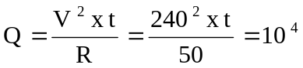
Time = 8.7 s (3 marks)

Q7. Key idea is that the current flow in the starter motor circuit is much greater than that in the lights circuit. Therefore to reduce losses the starter motor cable needs to have as low a resistance as possible (P = I²R). In the lights circuit the current is less so reducing the losses is not as important. (3 marks)

Q8. (a) E = V q = V x Ι x t
= 12 x 2.0 x (10 x 60)
Energy = 1.44 x 10⁴J (2 marks)
(b) q = Ι x t
= 2.0 x 600
Charge = 1.2 x 10³ C (2 marks)
Q9. (a) Initial temperature of hot water and mass of hot water. (2 marks)
(b) The temperature of test tubes A and B at the same time interval. (2 marks)
(c) Temperature in each tube was, after a few min, different and the test tube that had the largest temperature drop was the least suitable material for a wet suit for Aaron.
(1 mark)
Q10.
- Key idea is so that the only variable is the type of substance and no other variable needs be taken into account. (2 marks)

- A. (around 60º C) (2 marks)

(c) C. The slope is the least so that it takes a longer time to cool through a given temperature range. (2 marks)
(d) A. The time taken to change phase for A takes the longest time. (2 marks)

Q11. Substance C. (1 mark)
It changes phase at about 25 ºC. The physics involved is that C changes phase at this temperature and will not exceed 25 ºC until all the solid has turned into a liquid. This will take a long time by which it will be evening and cooler. (3 marks)
(It has the additional benefit that in winter warm days and cool nights will be insulated)

Q12. (a) (1 marks)

(b) The longer leads will have a higher resistance and there will therefore be a voltage drop over them. The voltage drop over the floodlight will therefore be less than 240 V and the current through it less than the first one. (2 marks)
(c) P = I x V
1200 = I x 240
I = 5 amps (2 marks)

Q13. (a) Key idea is that a towel is an insulator, mention reason that it contains air spaces.
(2 marks)
(b) The water evaporates and evaporation is a cooling process (no details needed).
(2 marks)

Q14. + 5 nC - 10 nC

(a) (2 marks)

(b) Force (1 mark)

(c) Both balls will have a charge of -2.5 nC, and they will REPEL. (2 marks)

Q15. Key idea is that the two strips expand differently and since riveted together will bend. This causes the electrical circuit to be completed and the alarm will be activated. Metal on the top must expand less so the bending will be upwards. (3 marks)

Section B
Q1. (13 Marks)
(a) Key idea is that the compact fluro do not become hot when used and so are more efficient. (1 mark)
(b) 18 % (1 mark)

(c) The incandescent globe produces more heat because the temperature rise was greater. (1 mark)
(d) So that each globe received the identical operating voltage of 240V. (1 mark)

(e) Heat in (A) = 0.03 x 650 x (40 - 15) + 0.65 x 1000 x (40 – 15)
= 487.5 + 16250 = 1.67 x 10⁴ J (3 marks)]
Heat in (B) = 0.03 x 650 x (20 – 15) + 0.65 x 1000 x (20 – 15)
=57.5 + 325 = 3.3 x 10³ J (2 marks)

(f) For A
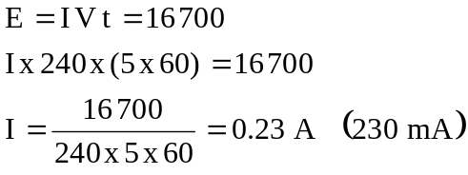 (2 marks)
For B
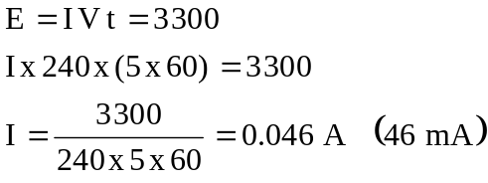 (2 marks)

Q2 (13 Marks)
(a) 1 = 1.5V
2 = 0.45 A
3 = 0.33 A (3 marks)
(b) V = I.R
4.1 = 0.12 x R
R = 34.2 ohms (2 marks)
(c) Q = I t
= 0.12 x 5 x 60
= 36 Coulombs (3 marks)
(d) V = I R
1.5 = 0.45 R
R = 3.33 ohms (2 marks)

(e)
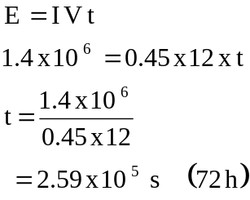 (3 marks)
Q3. (13 marks)
(a) Stirring, choosing suitable mass of liquid, temperature rise and appropriate time for
heating. (2 marks)
(b) Q = 0.25 x 4180 x (55- 20) = 36 575 J
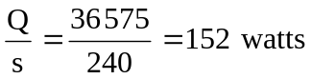 (3 marks)
(c) Some heat goes into heating the glass beaker and the gauze.
Not all heat from Bunsen heats the beaker, some heat “exits” sideways.
Thermometer accurate to only 1 degree in 35 => 3 % error, [accept +- 0.5ºC so 1%]
(2 marks)
(d) Bunsen in same position.
Bunsen flame same colour (2 marks)
(e) 220 x 153 = 0.35 x c x (65-25)
33 660 = 14 c
c = 2404 J kg^{.-1}K⁻¹ (4 marks)
Q4. (13 Marks)
(a) Insulation to reduce errors due to heat loss (and gain).
Weighing ice before adding introduces errors due to handling and warming during transfer. (2 marks)
(b) So ice was added and not ice surrounded by layer of water (melted ice) (1 mark)
(c) So heat lost initially due to temperature difference could be (approx) balanced by
heat gained when experiment was cooler than the surroundings. (2 marks)
(d) Heat lost by ice = 0.035x L + 0.30 x 4180 x (20-0)
Heat lost by the water = 0.10 x 4180 x (40-10)
Heat lost = Heat gained
0.035x L + 0.035 x 4180 x (10-0) = 0.10 x 4180 x (40-10)
0.035 L + 1463 = 12 540
L = 3.16 x 10⁵ J kg⁻¹ (6 marks)
(e)
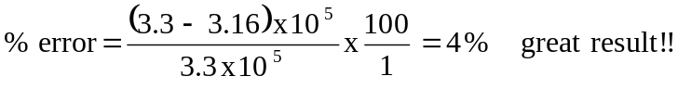 (2 marks)

Q5. (11 Marks)
(a) Key idea is to reduce heat loss from the hot liquid to the outside. (1 mark)
Resistance is 240/2.5 = 96 ohms (2 marks)
(b) Key idea is that there is no temperature change of the apparatus (no Δt ) while the experiment is running so no heat is required. (2 marks
(c)
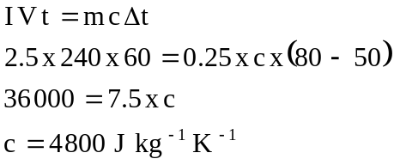 (5 marks)
- Gases (1 mark)

Q6. (11 Marks)
(a) (3 marks)
Resistance of selected length (L) of wire (ohms)
10
20
33
40
50
(b) see graph (3 marks)
(c) As the length of the wire increases then the resistance increases. (1 mark)
(d and e) See graph (2 +2 marks)

Q7. (15 Marks)
(a) That means a 50 ohm resistor is within the range 49 – 51 ohms. (1 marks)

(b) 10 = 0.06 x R R = 167 Ω (2 marks)
(c) 
 

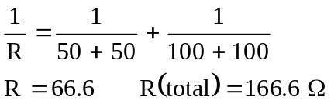

(2+2 marks)

 (d) V = I x R
10 = 0.031 x R R = 323 Ω      (2 marks)

R (total) = 100 + 100 + 100 + 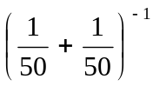
= 325 Ω (2+2 marks)

- Key idea is that if the network becomes HOT then the resistor values change. (2 marks)                            

Q8. (11 Marks)

(a) Heat lost by water transferred to heat gained by ice in melting and then reaching to
9 ⁰C was complete.
The temperature stabilized at a constant temperature of 9 ⁰C. (2 marks)

(b) Heat lost = Heat gained
0.2 x 4180 x (20 - 9) = 0.025 L + 0.025 x 4180 x (9 – 0)
9196 = 0.025 L + 940
L = 3.30 x 10⁵ J kg⁻¹ (4 marks)

(c) m x 2.25 x10⁶ + m x 4180 x (100 - 60) = (0.20 + 0.025) x 4180 x (60 - 19)
m x 2.417 x 10⁶ = 4.79 x 10⁴
m = 0.0198 kg (20 g) (5 marks)

END OF SECTION B

Section C
Q1. (10 marks)
Heat in over 2 min period (J x 10⁵) | Temperature    Φ _{2 } ( ºC)] | Temperature        Φ ₁ ( ºC) |       Φ _{2 } -    Φ _{1   } ( ºC)       
7.6 | 80 | 55 | 25
3.8 | 70 | 57 | 13
2.2 | 55 | 49 | 6
2.9 | 40 | 31 | 9
4.5 | 35 | 20 | 15
(2 marks)

(3 marks)

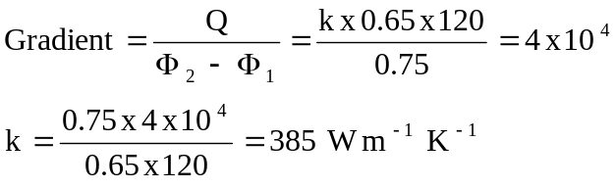(units irrelevant?)
(5 marks)

Q2. Firewalking. (20 marks)
1. Reduced by factor of (⅓)² ie reduced to one ninth of original value. (1 mark)

2. The air in the oven is at a very high temperature but there is very little of it. The air in the oven would have a mass of <100 g and the air in contact with your hand would only have a mass of a few grams. Also air is a poor conductor of heat. (2 marks)

3. The steel tray in the oven would have a mass of approx. 1 kg so the steel tray would contain more heat energy than the air. The key point is that steel is an excellent conductor of heat so the steel supplies sufficient heat to your fingers to burn your skin. (2 marks)

4. The coals change colour for a short time and the firewalker has blisters on his feet.
(2 marks)

5. The coals are “fluffy bits of charcoal”. They contain little heat energy since they have such a small mass. Also because they are poor conductors very little heat is transferred. (3 marks)

6. They walk quickly so that the time they are in contact with the coals is small, few seconds. (1 mark)

7. The firewalkers feet will burn. This is because the heat transfer is very good since the hot plate is metal and so a good conductor of heat. It is heat energy not temperature that hurts! (3 marks)

8. The filling has both more mass and higher specific heat. The crust can cool easily, it is on the outside and has a low mass, is full of air and as such is a poor conductor of heat. (3 marks)

9. The important physics is temperature difference between the boiling liquid and the skins temperature. This makes a great contribution that the difference in the specific heats. See calculations, assuming skin temperature is 20 ⁰C.

water Q = 1 x 4180 x (100 - 20) = 335 k J
Oil Q = 1 x 2090 x (300 - 20) = 585 k J (3 marks)

END OF EXAM

